Decision management directive

# Document purpose

The purpose of this document is to declare a formal procedure for decision management for the AgroxTech group.

# Purpuse of decision management

The purpose is to ensure that AgroxTech selects the most beneficial course of project actions where alternatives exists.

# Operations

We do so by implementing “*decision gates*”, which are to be considered approval events in our schedule. For each gate, we specify entry and exit criteria, and define the time where they are included into the project management baseline.

## Decision analysis

During each decision gate, we will apply decision analysis, which is a systematic approach for selecting the optimal choice among a set of alternatives when faced with uncertainty. This approach employs a probabilistic assessment of potential outcomes associated with each alternative and calculates the expected value of the outcome to determine the optimal choice.

To execute our decision analysis, we will be guided by the following 10 principles:

1. Gain a comprehensive understanding of the business situation by gathering relevant information and analyzing it systematically.
2. Utilize a value creation framework to identify and assess potential opportunities and use this lens throughout the decision-making process.
3. Establish clear and specific objectives and make the trade-offs that must be made, in order to achieve them, explicit.
4. Conduct a thorough investigation to uncover and formally frame the underlying problem(s) that need to be solved.
5. Generate a range of creative and unique alternatives that have the potential to address the identified problem(s).
6. Identify and consult with relevant experts in order to gather meaningful and reliable information, and to assess the feasibility and potential impact of proposed solutions.
7. Recognize and embrace uncertainty as an inevitable part of the decision-making process and use it as a catalyst for improving future performance.
8. Avoid getting stuck in "analysis paralysis" situations by setting clear deadlines and decision criteria, and by prioritizing action over analysis when appropriate.
9. Apply systemic thinking to develop a holistic understanding of the current situation, and to identify the key factors that will shape future outcomes.
10. Foster learning and clarity of action by engaging in productive dialog with stakeholders, seeking feedback and input, and encouraging constructive debate and discussion.

At last, we will be using decision trees to evaluate alternatives. An example of a decision tree can be found below:

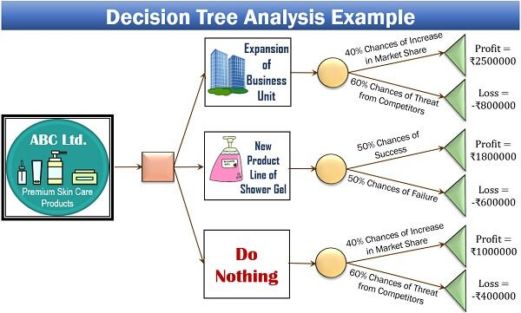

Figure 1: decision tree example.

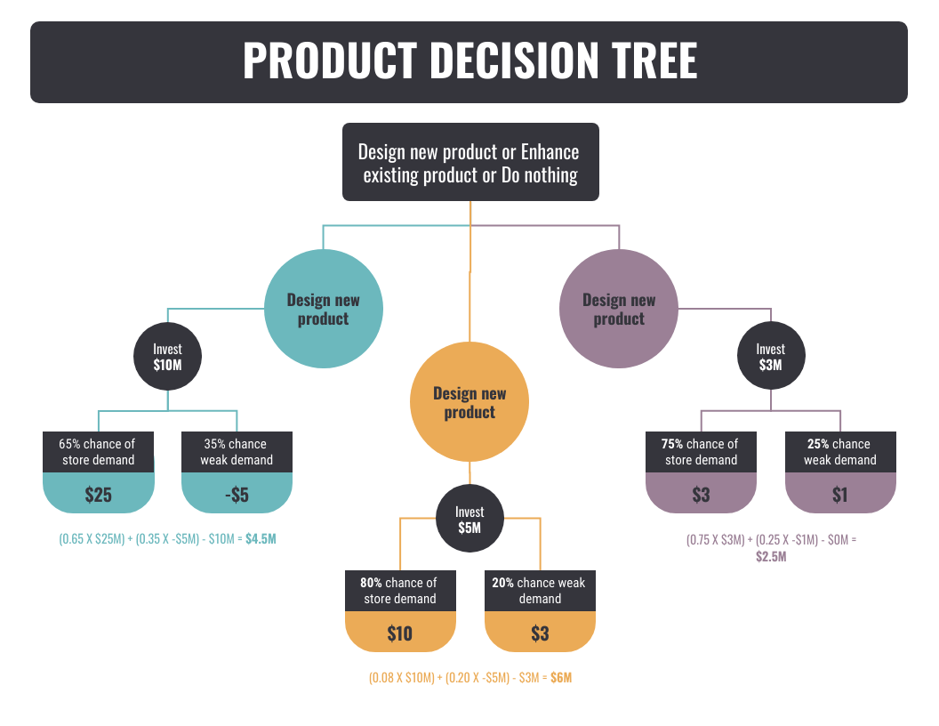

Figure 2: Decision tree analysis example.

Figure 2: decision tree example.